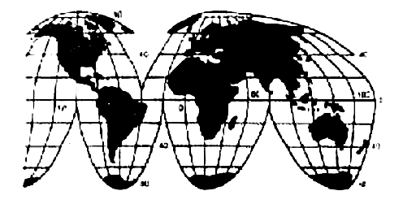 | 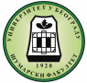
World Association of Soil and Water Conservation – WASWAC | University of Belgrade, Faculty of Forestry, Serbia

3rd WASWAC Conference

Dear Sir/Madam,

It is our honor and pleasure to invite you to participate in the 3rd WASWAC Conference, which will be held from 22nd to 26th of August 2016 in Belgrade, Serbia. This important event is organized by the World Association of Soil and Water Conservation (WASWAC) and Faculty of Forestry (Belgrade University).

Please visit our homepage to see further details as well as the important deadlines.
http://3rdwaswacconference.sfb.bg.ac.rs/index.html

We are looking forward to welcome you in Belgrade!

Best regards,
Organizing Committee

PS.: We kindly ask you to spread the word about our conference among colleagues.

President of Organizing Committee

Prof. Miodrag Zlatić, D.Sc.

E-mail: miodrag.zlatic@sfb.bg.ac.rs

Conference Secretariat, contact:
Katarina Lazarevic, Researcher,
Conference Secretariat,
E-mail: katarinalazarevic001@gmail.com
Natalija Momirovic, Researcher,
Conference Secretariat,
E-mail: natalijamomirovic@rocketmail.com

